Smart Irrigation System

Dheeraj Teella, Shreya Shree Padhi

Computer Science students specialized in IoT

Jain University, Bangalore

[dheerajnaiduofficial@gmail.com](mailto:dheerajnaiduofficial@gmail.com)

shreyapadhi01@gmail.com

*Abstract*—Internet of things (IoT) is a network of things, which is self-configuring. It has numerous applications in every field and makes life smart and effortless. One such application in the development of Smart Farming can make the production cost-effective and minimize the water wastage. The objective of this paper is to provide a novel way to reduce the water wastage smartly and automatically in agricultural fields by monitoring live data on temperature, pH level, and moisture levels in the soil. It helps to increase not only the production but also the quality of the products by detecting bugs. Soil moisture sensors, temperature sensors (DHT-11), and rain sensors collect the data and send it to farmers through a mobile application using Node MCU (esp8266).

Keywords—Node MCU, IR sensor, pH sensor, moisture sensor, DHT 11 temp and humidity sensor, dc motor, water sprinkler, gsm sim module.

# Introduction

Food is one of the four basic needs, and getting access to it is a primary function of an agricultural sector. Agriculture plays a main role in a country’s GDP, and also many people depend on it as employment. As India is a heavily populated country, it is difficult to meet the needs unless there is an increased rate of production in agriculture. And the new increase in the production rate demands a lot of other sources like land and water, which may lead to a water crisis in future generations since we are already short of it. But most of the time, farmers may feed more than the required amount of water to the fields, or forget to stop the supply. Such kind of problems related to water wastage in agricultural fields can be easily solved through modern technology. So, many have been trying to find ways to grow crops with less water, and that is where IoT can come in handy to fight with such agricultural problems.

IoT enables us to minimize the water wastage in the fields by regulating the supply of water. Arduino is used to switch-on or switch-off the water motor through android applications by receiving signals from sensors. These sensors (called soil moisture sensors) are placed in the soil to check the moisture levels. The IR sensor is placed to detect any moments of bugs and send this information. The pH sensor is placed to detect the nutrient level of soil and send the necessary information to the farmers. The information is even sent to the mobile sim card through a message by using a gsm sim module. It’s a precautionary measure to make sure the information has reached to the farmers even when the data is off.

# Ease of Use

## IoT Application in Agriculture :

Various sectors like industrial, automobile, smart homes, and smart cities are using IoT to make everything convenient and intelligent. Nowadays the agriculture sector is also using this technology for several benefits, which has led to the advancement of “AGRICULTURAL Internet of Things (IoT)”

## Crop Water Management :

Adequate water is essential to perform agriculture activities efficiently. Agricultural IoT is incorporated with Sensor Observation Service and Web Map Service (WMS) to ensure proper water management and to reduce water wastage in the fields.

## Precision Agriculture :

Weather information with high accuracy is required to reduce crop damage. We can obtain such precise information about weather prediction and soil quality whenever needed through Agricultural IoT.

## Integrated Pest Management or control (IPM/C):

Agriculture IoT systems assure farmers with accurate environmental data via proper live data monitoring of temperature, moisture, plant growth, and level of pests so that proper care can be taken during production.

## Benefits of IoT in Agriculture :

The following are the benefits of IoT in Agriculture:

1. We can collect, manage, and access data anywhere from sensors and cloud computing services (like Agriculture fields’ maps) through live monitoring and by enabling end to end connectivity among the concerned devices with the help of IoT.
2. IoT is regarded as a key component for Smart Farming as with accurate sensors and smart equipment’s, farmers can increase food production by 70% until the year 2050 as depicted by experts.
3. With IoT productions, costs can be reduced to a remarkable level which will in turn increase profitability and sustainability.
4. With IoT, efficiency level would be increased in terms of usage of Soil, Water, Fertilizers, Pesticides, etc.
5. With IoT, various factors would also lead to the protection of the environment. It is estimated that by 2050, 2 Billon Farms are likely to be connected to IoT.

# The novel proposed IoT based smart agriculture system

In today’s era of IoT, lots of new research in terms of Smart IoT based product development is being carried out to facilitate Smart Farming (Crop Water Management, Agriculture Precision, and IPM/C) via different kinds of sensors and drones to monitor agricultural fields.

Here, in this segment, we will discuss how the Smart IoT based Agricultural System is developed to monitor various parameters like Temperature, Moisture, Bugs, Soil nutrients (pH) using Arduino, Cloud Computing, and Solar Technology.

## Definition-Smart Agriculture IoT :

Smart Farming or Smart Agricultural System is viewed as an IoT contraption, which monitors live environmental data using different kinds of sensors depending on the parameters needed. This is based on the concept of “Plug & Sense”, in which farmers can execute ‘smart farming’ by simply placing the device on the field and accessing live data via sensors through Smart Phones or Tablets. Farmers can also share this collected data with agriculture consultants through Cloud Computing technology integration. This device enables the analysis of various sorts of data via Big Data Analytics from time to time.

## Components:

In this section, various components i.e., Modules and Sensors being used for Smart IoT Agricultural Stick development is discussed:

* Modules

Node MCU (esp8266) – Node MCU is a arduino device which has built in wifi modem. It can be connected to a power supply by an usb port. It is re-programmable through arduino ide software. It is used in many iot related devices.

Memory:128kBytes

Developer: ESP8266 Opensource Community

Operating System: XTOS

CPU: ESP8266 (LX106)

Storage: 4Mbytes

Power: USB

* BREAD BOARD :

“BreadBoard is a construction base used for building electronic prototypes”[4]. We can connect different sensors and electrical appliances through jump wires.

* BREAD BOARD POWER SUPPLY:

Power Module designed for MB102 breadboard

Technical Specifications: Compatible to 5V or 3.3V

Output Voltage: Output current<650mA; suitable for Arduino, AVR, PIC, ARM.

* Solar Plate:

6 Watts High-performance solar panel utilizes highly. Efficient crystalline solar cells to increase light. Absorption and improve efficiency.

Technical Specifications: 0.53mA; Voltage: 11.2V

Battery: Li-Ion 11.2 V battery is made of 3 A-Grade 18650.

* Sensors

## A. TEMPERATURE AND HUMIDITY SENSOR(DHT11):

“DHT11 is a Humidity and Temperature Sensor, which generates calibrated digital output. DHT11 can be interface with any microcontroller like Arduino, Raspberry Pi, etc. and get instantaneous results. DHT11 is a low-cost humidity and temperature sensor which provides high reliability and long-term stability. It uses a capacitive humidity sensor and a thermistor to measure the surrounding air and outputs a digital signal on the data pin (no analog input pins needed). It’s very simple to use, and libraries and sample codes are available for Arduino and Raspberry Pi. This module makes it easy to connect the DHT11 sensor to an Arduino or microcontroller as includes the pull-up resistor required to use the sensor. Only three connections are required to use the sensor- Vcc, Gnd and output. It has high reliability and excellence long-term stability, thanks to the exclusive digital sign acquisition on technique and temperature and humidity sensing technology.”[4]

It has 4 pin single row output, it can measure humidity upto 20-90%RH range and temperature upto 50 degree centigrade.

## SOIL MOISTURE SENSOR:

“Soil Moisture Sensor is used for measuring the moisture in the soil and similar materials. The sensor has two large exposed pads that function as probes for the sensor, together acting as a variable resistor. The moisture level of the soil is detected y this sensor. When the water level of the soil is detected by this sensor. When the water level is low in the soil, the analog voltage keeps increasing as the conductivity between the electrodes in the soil changes. This sensor can be used for watering a flowering plant or any other plants that require automation.

Technical Specification: 3.3V to 5V; Analog Output; VCC External 3.3V to 5V.”[4]

## PH METER :

“Gravity: Analog pH Sensor – Meter Kit Analog pH Sensor/Meter Kit specially designed for Arduino controllers and has convenient and practical “Gravity” connector and a bunch of features. Instant connection to your probe your Arduino to get pH measurements at $±$ 0.1pH (250C).”[4]

D. INFRA RED SENSOR:

“This is a multipurpose infrared sensor that can be used for color detection. The sensor provides a digital as well as analog output. An onboard LED is used to indicate the presence of an object. This digital output can be directly connected to an Arduino, Raspberry Pi, or any other microcontroller to read the sensor output.

IR Sensors are highly susceptible to ambient light and the IR sensor on this sensor is suitably covered to reduce the effect of the potentiometer should be used to calibrate the sensor.

An Infrared Light-Emitting Diode (IR LED) emits light of infrared range 700 nanometers (nm) to 1mm. This light is not visible by naked eyes but can be seen by a camera (that is why these are also used in night vision cameras).

A photodiode gives a response in terms of change in resistance when light falls on it. That change is measured in terms of voltage.

An IR LED and Photodiode are used in a combination of proximity and color detection. An IR LED (transmitter) emits IR light, that light gets reflected by the object, receiver (Photo Diode). The amount of reflection and reception varies with distance. This difference causes to change in input voltage through IR input. This variation in input voltage is used for proximity detection.”[4]

## GSM Module Arduino :

The GSM sim module is a device that is used to establish communication between computing system and GPRS or GSM system.

# Live Implementation and Real-time Data Analysis And monitoring

In this section, the overall working of the system is being discussed. The software used is Arduino IDE and the cloud platform used is blynk or thingspeak.com. The microcontroller NODE MCU is placed on the breadboard. It can be powered by a solar battery by connecting via a USB port. The code is uploaded via the Arduino IDE open-source platform. All the sensors are connected to the microcontroller via jump wires and breadboard. Then a dc motor is connected to the microcontroller along with tubes and water sprinklers. The code is then uploaded, and it is connected to the solar battery. This IoT device collects the information about the water moisture level in the soil and sends information to the farmer via blynk mobile application and at the same time, it sends a signal to pump the water and sprinkle in the field through sprinklers. This device also detects the movements of bugs and notifies the farmers, collects information about nutrients in the soil, and sends the data, measures the temperature of the crops which helps farmers in understanding the growth of crops because each crop has its temperature to sustain and grow. All the information is not only sent and recorded in the cloud platform but also is sent to the mobiles of farmers via SMS by using the gsm module.

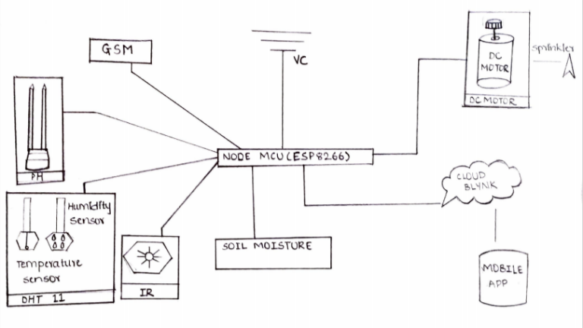

Figure 1.1 Diagram

# Result

This image describes the storage of environmental parameters temperature, humidity, clouds and moisture percentage in the cloud where x-axis consist of time and date and the y-axis consist of the parameter that is sensed by the sensor. This data can be retrieved in the form of excel sheet for future analysis.

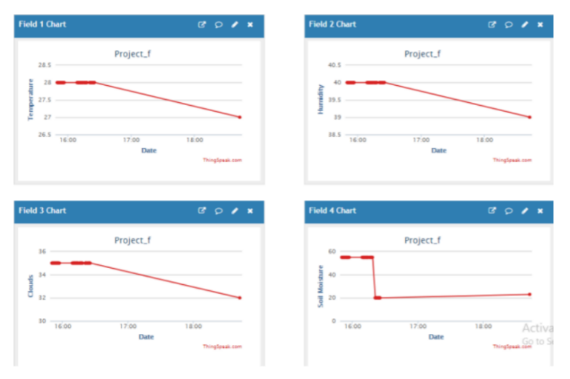

Figure 1.2 Chart

# Conclusion

This smart irrigation device can be availed at a very low cost. Which is a big boon for all the farmers across the globe. It is designed in such a way that it helps in saving water to maximum extent. With placing multiple sensors in the soil, water can be provided to the required piece of land. This device doesn’t require high-cost maintainance. It is simple to maintain and can be affordable. By using this device crop production will be increased. It is also estimated that in the future by using more advanced machine learning algorithms this device can be upgraded in such a way that it helps in mass crop production and reduce water wastage.

##### References

1. International journal of Scientific and Engineering Research. volume 8, issue 5, may 2017. ISSN 2229-5518. AN IOT BASED SMART IRRIGATION SYSTEM.
2. International Research journal of Engineering and Technology (IRJET) .

Volume 5, issue 6, june 2018. SMART IRRIGATION SYSTEM BASED ON SOIL MOISTURE. S Nalini durga , M Rama Krishna

1. C.Arun, K.Lakshmi Sudha “Agricultural Management using Wireless Sensor Networks-A Survey “2nd International Conference on Environment Science and Biotechnology IPCBBEE vol.48 (2012) © (2012) IACSIT Press, Singapore 2012.
2. Wikipedia.com
3. International journal of Advanced research,ideas and innovations in Technology- study on smart irrigation using iot.

**.**